Core Conditioning Exercises
January 8, 2011

Why Core Conditioning?
Most researchers consider the “core” to be the muscles and connective tissue that surround and stabilize the spine and pelvis. The core muscles provide a foundation for movement in the extremities and are therefore very important in running effectively and preventing injury. It is the core muscles that make it possible for humans to stand erect, walk, shift body weight, and change directions. It is important to develop the core muscles in a balanced way. Focusing on only one set of muscles within the core, for example, the abs, may result in destabilization and misalignment of the spine. Thus, a core exercise program should focus on all of the major muscle groups that surround the spine.

Following is a good excerpt from the Guilford Orthopedic and Sports Medicine Department webpage describing the purpose of the core

A mental image to understand the purpose and importance of the core is imagining a wagon wheel. The hub of the wagon wheel represents the core as the spokes of the wagon wheel represent the extremities of the body. All of the energy to move the wagon is created, controlled, and transferred at the hub of that wheel.

The same is true of our anatomical core. The kinetic energy to propel and sustain our bodies in motion needs to travel through our core. The core has a continuous cycle of creating, controlling, and transferring kinetic energy in a three dimensional manner.

During the running gait cycle, kinetic energy begins from when the heel makes contact with the ground engaging the hamstrings. The kinetic energy is then transferred into the core causing pelvic rotation to swing the opposite leg forward. If a runner’s core is weakened, there is an inefficient transfer of the kinetic energy. Inefficient motion can cause another body part to receive more than its share of the kinetic energy to dissipate. As a result, over a period of time, an injury to other body parts can occur. Therefore, minimizing unnecessary movements of the limbs improves efficiency and conserves energy.

Source: http://www.guilfordortho.com/running_core.htm
What impact could an unstable or weak core have on performance? A weak or unstable core could lead to bad posture, increased lower back motion, pelvic drop, or decreased spine rotation, which could cause a breakdown of form, especially late in a race and could ultimately lead to injuries and chronic lower back pain.

An excerpt from “Case for cross-training, part 2: Strength training for joint stability and injury prevention:

Most runners, particularly those who do not cross-train, are weak in key stabilizing muscles. As a result, the body is forced to absorb impact in a way it's not built to handle.
"The biggest thing I see is that runners have very weak core musculature, and because of this they can't control their posture while they're running," says Michael Fredericson, M.D., a running injury expert at Stanford University."Their pelvis goes into a forward tilt and they get an arch in their low back." This, Fredericson, says, results in extra stress on both the hamstrings and knees.
The hips are also problematic in many runners."The hip abductors and external rotators of the hip tend to be weak, or they're just not firing appropriately -- they're not becoming active when they should," says Bryan Heiderscheit, P.T., Ph.D., who directs an injury clinic for runners at Des Moines University in Iowa."You'll end up assuming an internally rotated position at the knee and at the hip." This can cause injuries ranging from knee pain to tendonitis in the hips and groin.

Source: http://www.active.com/running/Articles/Case_for_cross-training__part_2__Strength_training_for_joint_stability_and_injury_prevention.htm

Primary Core Muscle Groups
Different experts include different muscles in the core muscle group therefore what constitutes the core is somewhat arbitrary. The groups most often included are the rectus abdominis, internal and external obliques, transverse abdominis and erector spinae.

Muscle | Function(s)/Location
Rectus Abdominis  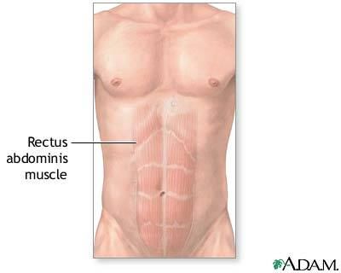 | - The “6 pack” – Sits on top of other abdominal muscles running from the center of the rib cage to the pubis bone.  - Primary function is to retain pelvic alignment, which also protects the spine  - A strong tendinous sheath called the "linea alba," or white line, divides the rectus abdominis down the middle, and three more horizontal tendinous sheaths give the muscle its familiar "washboard" look in very fit athletes.  - The rectus abdominis helps to flex the spinal column, narrowing the space between the pelvis and the ribs. It is also active during side bending motions and helps stabilize the trunk during movements involving the extremities and head.
External Obliques  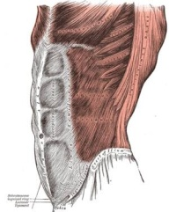 | - A pair of muscles positioned slightly to each side of the abdomen  - Help with twisting and tilting.  - The muscle fibers of the external obliques run diagonally downward and inward from the lower ribs to the pelvis, forming the letter V. You can locate them by putting your hands in your coat pocket.  - The external obliques originate at the fifth to twelfth ribs and insert into the iliac crest, the inguinal ligament, and the linea alba of the rectus abdominis.  - The external oblique muscles allows flexion of the spine, rotation of the torso, sideways bending and compression of the abdomen.
Internal Obliques  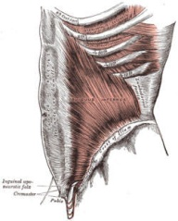 | - A pair of deep muscles that are just below the external oblique muscles.  - The internal and external obliques are at right angles to each other. The internal obliques attach from the lower three ribs to the linea alba and from the the inguinal ligament to the iliac crest and then to the the lower back (erector spinae).  - The lower muscle fibers of the internal obliques run nearly horizontally. Along with the external obliques, the internal obliques are involved in flexing the spinal column, sideways bending, trunk rotation and compressing the abdomen.  - Because of their unique alignment, at right angles to each other, the internal and external obliques are referred to as opposite-side rotators. When the trunk rotates left, the external obliques (on the right) contract. When the trunk rotates to the right, the external oblique fibers (on the left) activate the movement.
Transverse Abdominis  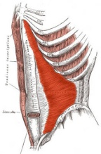 | - Deepest of the abdominal muscles  - The transverse abdominal muscle wraps around the torso from front to back and from the ribs to the pelvis  - Assist in flexing and twisting and protect the organs.  - Creates a strong link between the upper and lower portions of the body  - This muscle doesn't help move the spine or the pelvis, but it does help with respiration and breathing. This muscle helps facilitate forceful expiration of air from the lungs, stabilizes the spine and helps compress the internal organs.
Hip Flexors  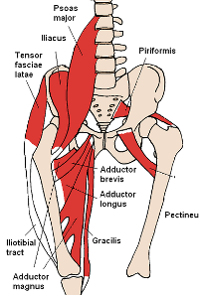 | - The hip flexors include several separate muscle groups  - The hip flexors are a group of muscles that bring the legs and trunk together in a flexion movement. The hip flexors are not technically abdominal muscles, but they do facilitate movements during several ab exercises.  - The muscles that make up the hip flexors include:  - psoas major  - illiacus  - rectus femoris  - pectineus  - sartorius
Erector Spinae | A set of very small muscles that run up the spine on both sides from the neck to the lower back.
Multifidus | Under the erector spinae along the vertebral column, assist in extending and rotating the spine.

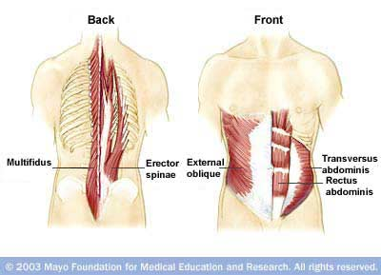

Specific Exercises

The Front Plank

Focus: Abdominal muscles, back, and stabilizer muscles

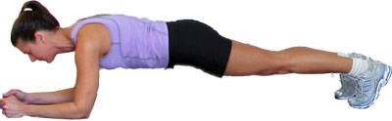

- Lie face down on a mat resting on the forearms with palms flat on the floor.
- Push up off the floor, raising up onto toes and resting on the elbows.
- Keep the back flat, in a straight line from head to heels.
- Tilt the pelvis and contract your abdominals to prevent your rear end from sticking up in the air or sagging in the middle.
- Hold for 20 to 60 seconds, lower and repeat for 3-5 reps.
Modification: The plank position can be altered so that body weight is resting on the knees rather than toes as below. The plank can also be done resting on the hands with straight arms rather than on the elbows.
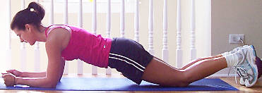

To increase difficulty:
Legs and arms can be raised for a count of 2 to 10 seconds (raise legs 5 to 8 inches off the floor)
Opposite arm/leg can be raised at the same time for a count of 2 to 10 seconds

Source: http://exercise.about.com/od/abs/ss/abexercises_10.htm

The Side Plank

Focus: Hip strength and stability
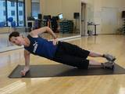
- Begin by laying on the side on the floor.
- Position the elbow on the floor just under your shoulder.
- Lift up on that elbow and keep the body stiff from head to toe.
- Hold this position for a count of 10 and lower the hip to the floor.
- Rest and repeat three times.
- Switch sides and repeat the exercise on the other hip.
Modification: Balance on the hand with a straight arm rather than the elbow.

To increase difficulty:
Lift the top leg up toward the ceiling. Repeat the leg lift 10 times slowly and return to the start position.

Source: http://sportsmedicine.about.com/od/strengthtraining/qt/Side_Plank.htm

The V Sit -

Focus: rectus abdominis, external obliques, internal obliques, hip flexors

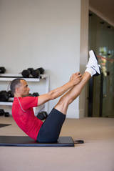
- Start in a seated position on the floor
- Contract your abdominal muscles and core, and lift your legs up to a 45-degree angle as pictured
- Reach your arms straight forward or reach up toward your shins as you are able.
- Maintain good core posture and a strong spine while you hold the position for 5-10 seconds.
- Bend the knees and bring the legs back to the floor to rest
- Repeat 3-5 times.
- Gradually increase the length the position is held for up to 30 seconds.

To increase difficulty: While retaining upper body V sit position, alternate bending and straightening legs from the knee. Another more difficult alternative is to do crunches while balancing in the “v” position – you can also add a side to side twist.

Source: http://sportsmedicine.about.com/od/abdominalcorestrength1/qt/V-Sit.htm

Bicycle

Focus: Rectus abdominis and obliques
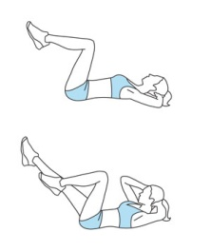
- Lie on the floor and lace your fingers behind your head.
- Bring the knees in towards the chest and lift the shoulder blades off the floor without pulling on the neck.
- Straighten the left leg out while simultaneously turning the upper body to the right, taking the left elbow towards the right knee.
- Switch sides, bringing the right elbow towards the left knee.
- Continue alternating sides in a 'pedaling' motion for 1-3 sets of 12-16 reps.
To increase difficulty: The closer the legs are to the floor the more difficult this exercise is.

Source: http://www.realsimple.com/health/fitness-exercise/workouts/stronger-abs-in-fifteen-minutes-00000000022852/page6.html

Crunches
There are several variations on the traditional crunch that work core muscles in different ways – the next several exercises are crunch variations. Altering the hand/arm position during the crunch is a simple way to vary and progress the exercise. Basic physics tells us that the load being lifted is equal to the weight of the object multiplied by its distance from the pivot point. In the crunch we can assume that the abdominals are the pivot point so any shifting of weight (moving the upper limbs) away from this point will make the crunch more difficult.

Regular Crunch
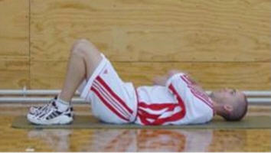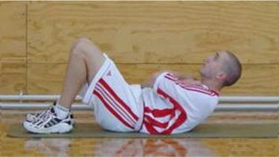
- Lie on the floor with your knees bent and feet flat on the floor
- Cross your arms over your chest
- Push the lower back into the floor
- Concentrate on curling your upper trunk as much as possible
- Exhale and slowly return to the start position
- During the entire movement the neck should be held straight with the eyes looking at the ceiling
Source: Source: http://pfitzinger.com/cc.shtml

Long Arm Crunch
Focus: Rectus abdominis
The long arm crunch adds a longer “lever” which makes this form of crunch a bit more challenging.
- Lie on a mat and extend the arms straight out behind the head with hands clasped, keeping the arms next to the ears.
- Contract the abs and lift the shoulder blades off the floor.
- Keep the arms straight and avoid straining the neck. If you feel neck pain, take one hand behind the head while keeping the other arm extended.
- Lower and repeat for 1-3 sets of 12-16 reps.

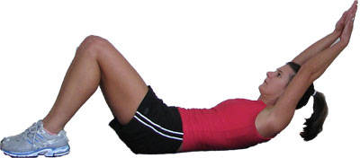

Source: http://exercise.about.com/od/abs/ss/abexercises_6.htm

Reverse Crunch
Focus: Rectus abdominis
- Lie on the floor and place hands on the floor or behind the head.
- Bring the knees in towards the chest until they're bent to 90 degrees, with feet together or crossed.
- Contract the abs to curl the hips off the floor, reaching the legs up towards the ceiling.
- Lower and repeat for 1-3 sets of 12-16 reps.
- It's a very small movement, so try to use your abs to lift your hips rather than swinging your legs and creating momentum.

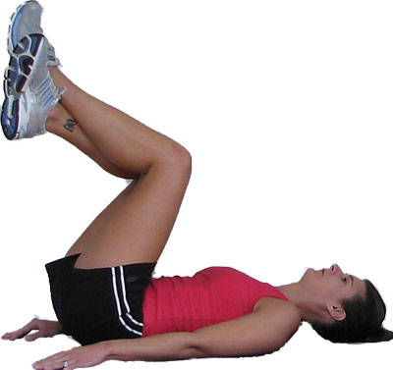

Source: http://exercise.about.com/od/abs/ss/abexercises_7.htm

Full Vertical Crunch
Focus: Rectus abdominis
- Lie on your back and extend the legs up towards the ceiling.
- Place hands behind your head (lightly cupping it) and contract the abs to lift the shoulder blades off the floor.
- At the same time, press the heels towards the ceiling, creating a 'u' shape with the torso.
- Lower down and repeat for 12-16 reps.
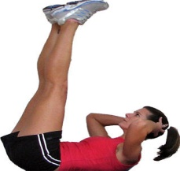

Crossover Crunch
Focus: Rectus abdominis, external obliques, internal obliques
- Lie on your back with your knees bent and feet flat on the floor.
- Cross your right leg over your left leg so your right ankle is resting on your left knee.
- Place your fingertips to the side of your head just behind your ears.
- Contract your abdominal muscles as though you are doing a crunch
- Slowly twist your torso and touch your left elbow to your right knee.
- Exhale as you lift up
- Slowly lower to the starting position
Source: http://sportsmedicine.about.com/od/abdominalcorestrength1/qt/crossovercrunch.htm

- Inhale as you lower
- Repeat for the desired number of repetitions and switch legs and do the same number of reps on the other side.

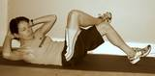

Side Crunches
Focus: Works internal and external oblique muscles
Starting Position: Lie on your back and turn both knees to the right side and on the ground.
Form: Exhale as you lift your shoulder blades off the floor. Even though your knees are turned to the side keep your upper body moving straight up and slightly to the left side. Hold at the top for 1 second and slowly lower. Repeat 8-15 times and switch sides.
Personal Trainer Tips: The range of motion may be less during this movement compared with regular crunches, but push yourself to hold the squeeze at the top.
Source: http://www.ab-core-and-stomach-exercises.com/index.html
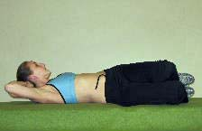
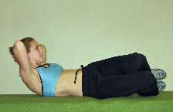

Side Ups  Starting position: Lie on your left side keeping your body and legs straight. Have a partner hold both legs just above the ankle. Place your right hand at your side. Fold your left hand across your chest (beginner) or clasp both hands behind your head (advanced).  Action: Slowly lift your head and left shoulder off the floor. Return to the starting position. Keep your hips perpendicular to the floor. Repeat the same exercise on the opposite side.  Source: http://www.nismat.org/orthocor/programs/abstr/abex.html/ | 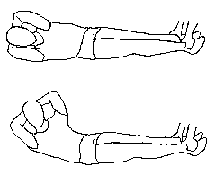

Superman
Focus: transversus abdominis and erector spinae
- Start facedown on the floor, with your arms and legs extended
- Raise your head, your left arm, and right leg about five inches off the floor.
- Hold for three counts, then lower.
- Repeat with your right arm and left leg.
- Do up to 10 reps on each side.
To increase difficulty: Raise both arms and legs at the same time
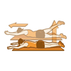

Bridge
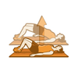
Focus: glutes and hamstrings
- Lie faceup on the floor, with your knees bent 90 degrees, your feet on the floor.
- Lift your hips and back off the floor until your body forms a straight line from your shoulders to your knees.
- Hold for five to 10 seconds. Lower to the floor and repeat 10 to 12 times.
To increase difficulty: Straighten one leg once your hips are lifted.

Focus: obliques
- Lie faceup on the floor with your knees bent and raised over your hips, with your ankles parallel to the ground, your feet lifted, and your arms extended outward.
- Rotate your legs to the left side, bringing your knees as close to the floor as possible without touching.
- Return to the center, then move your knees to the right side. Do 10 to 12 reps on each side.
Keep It Honest: Make sure not to swing your hips or use momentum; start the movement from your core and continue to move slowly from side to side.
To increase difficulty: Keep your legs straight.
Metronome
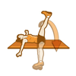

Source: http://www.runnersworld.com/article/0,7120,s6-238-263--13030-3-1X2X3X4-5,00.html

The Dead Bug
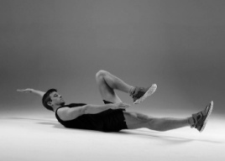
Focus: Trains your deep abs to maintain stability during alternating arm and leg movements
Lie face up with your head slightly elevated above the floor and engage your deep abs by drawing your navel towards your spine. Begin with your right leg fully extended and elevated a few inches off the floor, your right arm reaching towards your right foot, your left leg sharply bent with the knee drawn towards your chest, and your left arm extended straight behind your head, roughly parallel to the floor. Keeping your navel drawn towards your spine, slowly reverse the position of your arms and legs, and continue alternating arm and leg positions for 20 to 30 seconds.
Source: http://mattfitzgerald.org/article.php?id=15
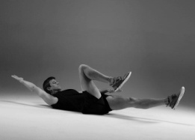

Supine Bent Knee Raises

Focus: multifidi-the deep transverse spine stabiliser and extensor of the lumbar spine
- Position yourself on a mat on all fours.
- While maintaining a midrange/neutral curve of the lumbar spine, raise the right arm and the left leg (opposite upper and lower limbs) into a line with the trunk, while preventing any rocking of the pelvis or spine (excessive transverse or coronal-plane motion). If it helps to maintain alignment, the athlete may use an object, such as a foam roller or wooden dowel, placed along the spine, for added tactile feedback. The leg should be raised only to the height at which athlete can control any excessive motion of the jumbo-pelvic region. Lower the leg and arm and repeat on the other side.
- Do 5 – 10 reps on each side.
Source: “Muscular Balance, Core Stabilit6y, and Injury Prevention for Middle and Long-Distance Runners” Michael Frederickson, MD, Tammara Moore, PT (2005)
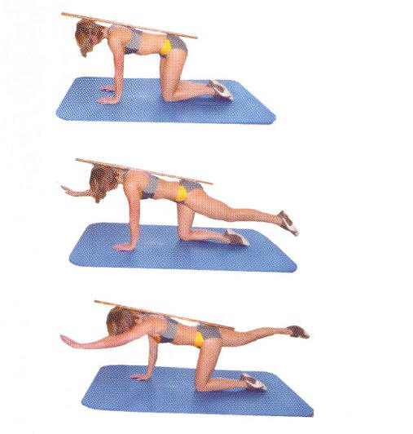

Push Ups
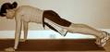
The push-up may just be the best body-weight exercise that builds upper body and core strength. Done properly, it is a compound exercise that uses muscles in the chest, shoulders, triceps, back, abs and even the legs.

Do It Right﻿
While on the floor, position your hands beneath your shoulders. Keep your body in a straight line from head to toe without sagging in the middle or arching your back. Keep a tight core throughout the entire push up. Slowly bend your elbows and lower yourself until your elbows are at a 90 degree angle. Then slowly push back up to the start position. Don't lock out the elbows; keep them slightly bent.

Source: http://sportsmedicine.about.com/od/sampleworkouts/tp/Body-Weight-Workout.htm

Back Extensions on the Floor

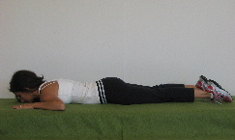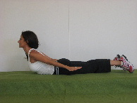
Starting Position: Lie on the floor, face down with your hands at the level of your head.
Form: Inhale and lift your chest off the floor. As you lift your chest off the floor, bring your arms towards your sides and squeeze your shoulder blades together.
Personal Training Tips: Turn your shoulders outwards so that your palms face away from your body.
Move in a slow and controlled manner, and hold at the top for 1 second before lowering back towards the floor.
Perform 10-20 repetitions per set, and stretch between sets if your lower back muscles feel tight.
Source: http://www.ab-core-and-stomach-exercises.com/lower-back-exercises.html

Other Resources
- All About-Abs.com – A very comprehensive website with hundreds of exercises including descriptions and photographs – includes exercises on the floor, with weights, stability balls, medicine balls, bosu balls and balance boards http://www.ab-core-and-stomach-exercises.com/index.html
- “Core stability and its relationship to lower extremity function and injury”, Willson, John D. MSPT et. al. access at http://www.udel.edu/PT/davis/Willson_2005.pdf
- “Enhancing Low-back Health through Stabilization Exercise - http://www.acefitness.org/pdfs/LowBackStabilization.pdf
- “Injury prevention for High School Female Cross Country Athletes – This article includes a program for strengthening core/hip flexor structure “http://commons.pacificu.edu/cgi/viewcontent.cgi?article=1003&context=ptfac
- “Muscular balance, Core Stability, and Injury Prevention for Middle and Long Distance Runners”, Frederickson, Michael, M.D. and Tammara Moore, PT access at http://www.med.nyu.edu/pmr/residency/resources/Clinics_sports%20med/runner%20muscle%20balance%20core_PMR%20clinics.pdf
- Nicholas Institute of Sports Medicine and Athletic Trama – Lots of good core and other exercises here under “orthopaedic sports medicine corner – therapeutic exercise programs” http://www.nismat.org/nismat
- “The Inner Unit” A discussion of research and some exercises by Paul Chek - http://www.coachr.org/innerunit.htm

